NSAA WRESTLING NEWSLETTER 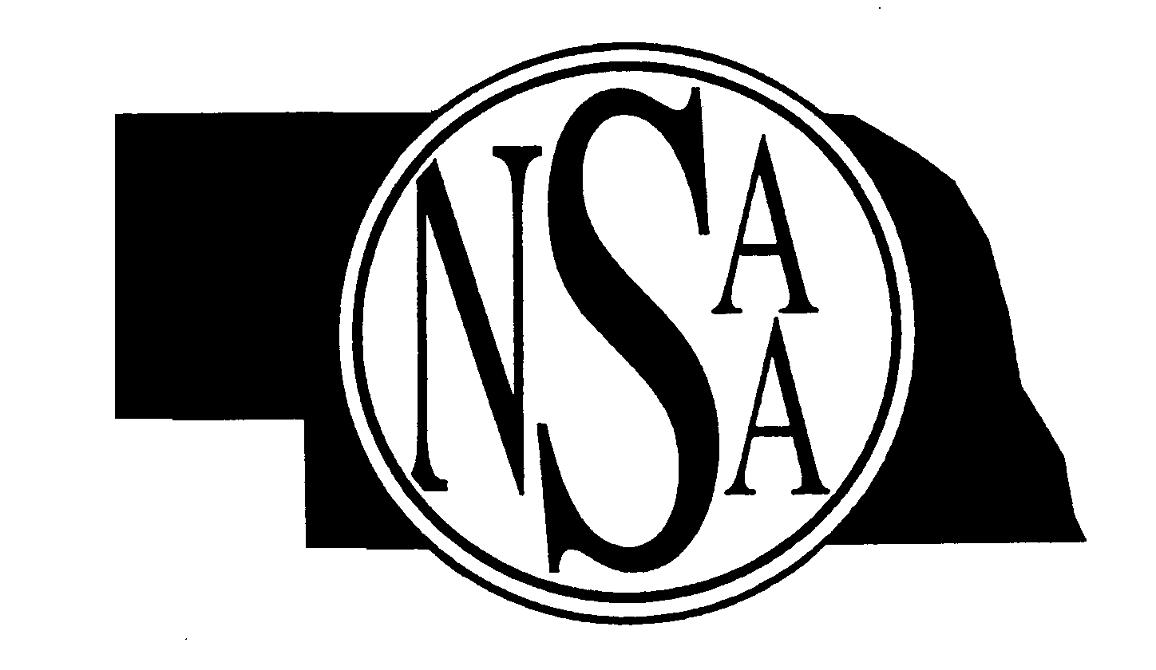


Volume #2 January 2006
A Publication by the Nebraska School Activities Association
for Wrestling Coaches and Officials registered with the NSAA
Edited by Bob Colgate, Assistant Director


Mailing Address: PO Box 5447, Lincoln, NE 68505-0447 Phone: 402-489-0386

COMMENTS
The wrestling season is about three-quarters complete with Districts and State only a month away. The wrestling season has gone very well so far from the NSAA perspective. We are asking all schools and coaches to work with the parents and/or spectators at all wrestling meets on proper sportsmanship. Coaches need to continue to remind their wrestlers that they are to keep their uniform on while in the competition area, both before and after each match. Best of luck at Districts!

DISTRICT WRESTLING ENTRIES
Reminder to all head wrestling coaches, that the deadline to submit your district wrestling entries is on or before January 30, 2006. Please refer to page 17 of the 2005-06 NSAA Wrestling Manual for information on how to submit your 2006 District Wrestling Entry Form. Please be sure to submit a copy of your NSAA Weight Certification forms for all of your wrestlers that you have entered in the District Tournament, along with your 2006 NSAA District Wrestling Entry Form.

WRESTLING EJECTIONS UPDATE
The following numbers represent the total number of ejections for wrestling as reported to the NSAA Office as of January 12, 2006: Wrestlers = 14 (9-Varsity, 5-JV); Coaches = 0 (0-Varsity, 0-JV)
Out of the 14 wrestlers who have been ejected, three have been because of biting – Flagrant Misconduct. Officials, if you have an ejection, please remember to file a report with the NSAA Office right after the meet is completed. As the season starts to come to a close, I encourage coaches and wrestlers to continue to work on following all of the NSAA Sportsmanship policies.

STATE WRESTLING TICKETS
As of January 12, 2006, reserved and general admission tickets are still available for all sessions. Just a reminder, once all of the reserved and general admission tickets are sold out for Friday night Semifinals and for Saturday, no more tickets will be sold. To order 2006 NSAA State Wrestling Tickets, please call the Qwest Center Omaha Box Office at (402)-341-1500.

REMINDERS FOR ATHLETIC DIRECTORS – COACHES – OFFICIALS
- All varsity and non-varsity meets need to follow all of the 2005-06 NFHS Wrestling Rules and the NSAA rules for wrestling.
- NFHS Rule 6-7-1 - (Overtime): There is no rest between the regular match and the overtime. Officials need to verify that the score is correct at the end of the regular match to make sure that overtime is necessary.
Cheerleaders can be near the edge of the mat during meets where space permits. Cheerleaders are not to pull the mat up over their legs so that they can pound on it. Also, cheerleaders can pound or slap the gym floor but not the mat as this can cause a distraction to the wrestlers and the officials. Officials need to remind all cheerleaders at all sites to make sure that they are spaced safely away from the mat and that they pay attention when the wrestlers and officials are coming out of bounds.
- Communicable Disease Procedures: ALL individuals who are dealing with blood or body fluids from wrestlers during a meet, need to wear rubber gloves at ALL times. Please follow the NFHS Communicable Disease Procedures as stated in the NFHS Wrestling Rule Book. Also, the host school is responsible for making sure someone is assigned to clean up the mats/wrestlers who have blood or body fluid on them. Officials are not to clean up blood or body fluid on the mats or wrestlers.

2005-2006 NFHS WRESTLING CASEBOOK SITUATIONS

SITUATION 1: Wrestler A reports to the mat with (a) shoe laces not properly secured or (b) biking shorts that extend below the 4-inch inseam of the trunks or properly cut one-piece uniform. In both (a) and (b) the referee charges Wrestler A with a technical violation (5-28-1f; 7-3-7). Wrestler A is also charged a time-out and has a maximum of 1 ½ minutes to correct the problem (8-2-1) and Wrestler B is awarded a match point. RULING: Correct. This action caused the match to be delayed in starting and is a violation that is to be charged to the wrestler. There is no penalty charged to the coach.
SITUATION 2: During the second period, Wrestler A’s ear guards come off during action. The referee notices Wrestler A is wearing an earring. The referee stops that match and charges Wrestler A with a technical violation for wearing jewelry (3-1-4a; 5-28-1f; 7-3-7). Wrestler A is also charged with a timeout and has 1 ½ minutes to correct the problem (8-2-1) and Wrestler B is awarded a match point. The coach of Wrestler A is also charged with unsportsmanlike conduct (5-31-1; 7-5-3). RULING: Correct. An earring is considered jewelry. The coach is charged with unsportsmanlike conduct as it is his responsibility to see that all competitors are properly equipped (3-1-4c) and this stoppage has put the opponent at a disadvantage by slowing the progress of the match (5-31-1; 7-5-3). COMMENT: Reporting to the mat with illegal equipment or being improperly attired will be charged to the individual as long as the match has not started. The coach will not be charged with any violation in this situation. Should illegal equipment be discovered after the match has started the wrestler will be penalized with a technical violation; as well as the coach being charged with unsportsmanlike conduct.
SITUATION 3: In a multiple school tournament being conducted in one day, there are: (a) eight schools invited, and it is announced four places will be scored; or (b) 16 teams are invited, and it is announced six places will be scored. RULING: Wrestlers are limited to no more than five matches, including forfeits, during a day. Matches are those for which the time limit is specified by rule and are six minutes in length for championship or five and six minutes in length for consolation. In (a), it would be possible for a school to conduct an eight-team tournament, wrestling back to four places, because this would consist of a maximum of four matches for any wrestler. In (b), if only the losers of the quarterfinal bracket go to the wrestle-back it could be completed in only five matches per day. If, however, the first-round losers enter the wrestle-back, there is a possibility that some contestants would be involved in six matches. This would not be allowed and would be in violation of Rule 1-2-2 which states, no wrestler shall represent the school in more than five matches in any one day. Therefore some consolation finals could not be wrestled. If one wrestler had wrestled in four matches and the other wrestler in five matches, then the wrestler with four matches would be the winner by forfeit. If it was the match for third place and both wrestlers had been in five matches, then they would both receive points for fourth place. There could be no one for third. (1-2-2)
SITUATION 4: During the match the referee notices Wrestler A has a bandanna underneath a legal hair covering. What should the referee do? RULING: The referee should stop the action, penalize A for technical violation, and charge the wrestler injury time while the bandanna is being removed. The coach is also penalized. (3-1-4c; 4-2-1; 5-31-1; 7-3-7; 7-5-3).
SITUATION 5: The visiting team’s coach in reviewing the total team points from the prior evening’s dual meet notices a mistake has been made in the addition of team scores and his team should have won by one point. What is the proper procedure for correcting this error in computation? RULING: The time frame for correcting the computation of a match score or team score is 30 minutes following the signing of the official scorebook. The team score shall not be changed. (3-1-3, 11)
SITUATION 6: Wrestler A has both arms of Wrestler B tied-up in such a manner that B cannot protect himself. A returns B to the mat. Would this be considered a slam? RULING: In this situation the amount of force needed to create injury is less due to B having limited ability to protect himself. A is responsible for the safe return to the mat. This could be a slam, if the referee judged it so. (7-1-1)
SITUATION 7: Wrestler A was not given the choice after Wrestler B had taken a second injury time-out during the second period. At the conclusion of the match, this was brought to the attention of the official by the coach. RULING: This is not a correctable error. This situation had to be corrected before the start of the third period. (6-6-1; 8-2-1)
SITUATION 8: The assistant referee believes Wrestler A is stalling and verbally shouts across the mat to the referee that A is stalling. RULING: In this situation the assistant referee should have walked behind the referee and communicated in such a manner as not to draw attention to himself. NOTE: The assistant referee should never outwardly disagree with a call or situation, but should always bring it to the referee’s attention immediately in a discreet manner, allowing the referee the opportunity to stop the match at the appropriate time, if necessary. (3-2-2)
SITUATION 9: The match is stopped to penalize Wrestler A for applying an illegal hold. The assistant referee is standing next to the coach of A. The coach disagrees with the penalty and asks the assistant for an explanation. RULING: Coaches are not permitted to address the assistant referee. The assistant referee should advise the coach of the proper procedure to approach the referee by coming to the scoring table and requesting a conference. The assistant referee shall supervise the two contestants during this conference. (3-2-2i; 6-6-6)
SITUATION 10: Wrestler A is in control while down on the mat. A locks hands around Wrestler B’s waist. The referee indicates locked hands and B stands up. B, seeing the locked-hand signal, returns to the mat while A’s hands remain locked. How many points are awarded? RULING: A never released the locked hands; therefore, it is the same situation and only one penalty point would be awarded. (5-28-1; 7-3-4)
SITUATION 11: Wrestler B maintains a defensive position. Each time B is broken down, he immediately returns to the starting defensive position in: (a) there is no attempt to escape or reverse; or (b) he attempts several times to stand up, but is prevented from doing so by Wrestler A. RULING: In (a), when a defensive wrestler refuses to aggressively attempt escapes or reversals, it is stalling. In (b), the defensive wrestler is not stalling when overpowered. (7-6-5, 7)
SITUATION 12: With the score tied at the end of the overtime period, Wrestler A has the choice for the tiebreaker. A chooses the top position. After 25 seconds have elapsed, A is injured. This is A’s second injury time-out. Wrestler B chooses the top position. B controls A for the remaining five seconds and is declared the winner. Is this correct? RULING: Yes. Even though B controlled A for only five seconds, B was the offensive wrestler when the period ended. (6-7-1; 8-2-1)

Nebraska School Activities Association
NON-PROFIT ORG.

U.S. POSTAGE
PAID

Lincoln, NE
Permit No. 269
8230 Beechwood Dr.
PO Box 5447

Lincoln, NE 68505-0447

RETURN SERVICE REQUESTED

